Date | 3 October 2026
Project Name | Automated Network Request Management
Maximum Marks | 4 Marks
Project Design Phase-II Technology Stack (Architecture & Stack)
Technical Architecture:
The Deliverable shall include the architectural diagram as below and the information as per the table1 & table 2
Architecture: Automated Network Request Management in ServiceNow
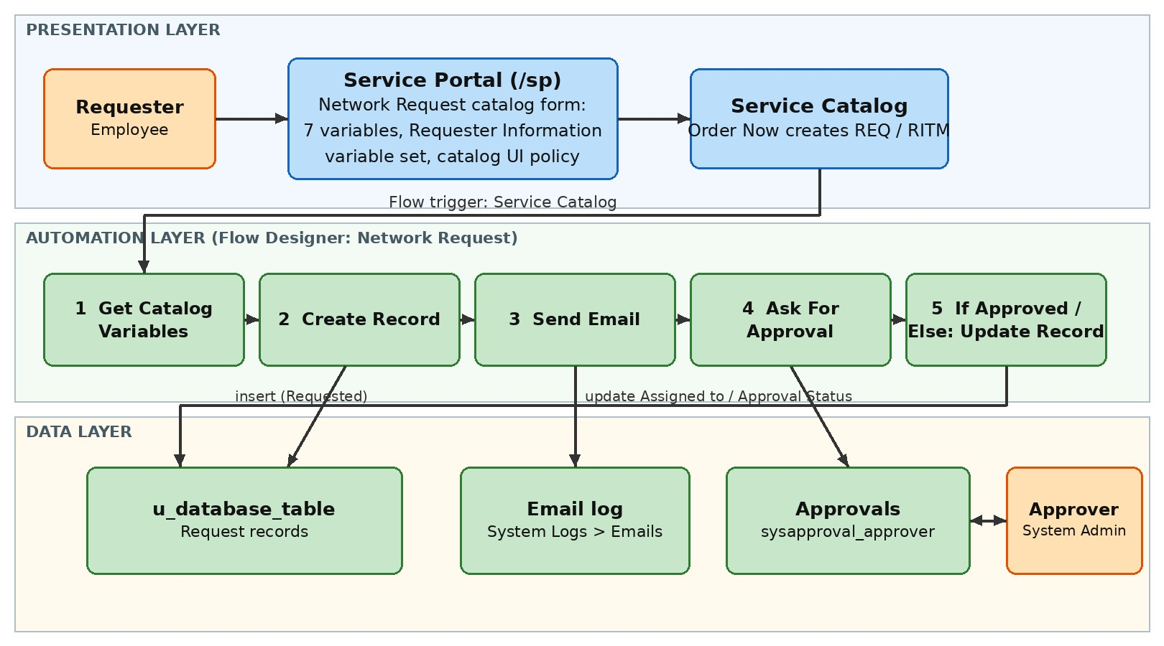
Table-1 : Components & Technologies:
S.No | Component | Description | Technology
1. | User Interface | Employees raise requests through the Service Portal catalog form (7 variables, Requester Information variable set, catalog UI policy) | ServiceNow Service Portal, Service Catalog, Catalog UI Policy
2. | Application Logic-1 | Flow "Network Request": triggers on Service Catalog submission, gets the catalog variables and creates the request record | Flow Designer (Service Catalog trigger, Get Catalog Variables, Create Record)
3. | Application Logic-2 | Approval logic: Ask For Approval to the System Administrator, then If/Else updates Assigned to and Approval Status | Flow Designer (Ask For Approval, If/Else, Update Record)
4. | Application Logic-3 | Notification logic: confirmation email with the request number | Flow Designer Send Email action; System Logs > Emails
5. | Database | Custom table u_database_table (string fields plus Assigned to reference to User); Approval Request relationship to sysapproval_approver | ServiceNow platform database
6. | Cloud Database | Data is stored in the ServiceNow cloud instance (Personal Developer Instance) | ServiceNow PDI (cloud)
7. | File Storage | Not used; the solution stores no files or attachments | Not applicable
8. | External API-1 | Not used; email is sent by the platform's own notification engine | Not applicable
9. | External API-2 | Not used | Not applicable
10. | Machine Learning Model | Not used | Not applicable
11. | Infrastructure (Server / Cloud) | Deployed on a ServiceNow cloud-hosted Personal Developer  Instance (Global scope)  Local server: not required  Cloud server: ServiceNow PDI | ServiceNow cloud (PDI)
Table-2: Application Characteristics:
S.No | Characteristics | Description | Technology
1. | Open-Source Frameworks | No open-source framework required; built on the ServiceNow low-code platform | ServiceNow low-code platform
2. | Security Implementations | ACLs on the custom table (read, write, create, delete); rolebased access; approval by System Administrator | ServiceNow ACLs and roles
3. | Scalable Architecture | Layered design (portal, flow logic, data table); new variables, approvers or tasks are added in Flow Designer without code | ServiceNow platform, Flow Designer
4. | Availability | Hosted on the ServiceNow cloud; a PDI is available while active and may hibernate when idle | ServiceNow cloud instance
5. | Performance | Event-driven flow that starts on submission, with no custom scripts; runs can be monitored in Flow Executions | Flow Designer, Flow Executions
References:
https://c4model.com/
https://developer.ibm.com/patterns/online-order-processing-system-during-pandemic/ https://www.ibm.com/cloud/architecture https://aws.amazon.com/architecture
https://medium.com/the-internal-startup/how-to-draw-useful-technical-architecture-diagrams-2d20c9fda90d

